# MVC

## Version

## Filters

* **Authorization** filters – Implements the **IAuthorizationFilter** attribute.
* **Action** filters – Implements the **IActionFilter** attribute.
* **Result** filters – Implements the **IResultFilter** attribute.
* **Exception** filters – Implements the **IExceptionFilter** attribute.

# WEB API

## References

Nick - Dometrain

## Intro to RESTful APIs

### Six constraints to make API services RESTful

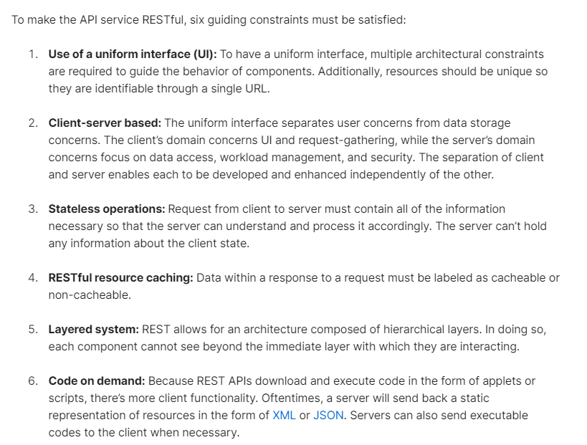

Source: [Link](https://blog.postman.com/rest-api-examples/)

## Beyond basic CRUD

## Authentication and Authorization

Authentication: Who is the user

Authorize: What user can do

Web APIs are stateless: So token will be passed as part of every request

Services to create or validate tokens: Azure, Aws, Auth0

Standard for token: Json web token

To keep tokens: azure key vault or aws secrets manager

Attributes: [Authorize] [AllowAnonymous]

Postman: Add the token in parent collection so that we don’t need to provide token for every API call

### JWT

Token contains Header, payload and signature.

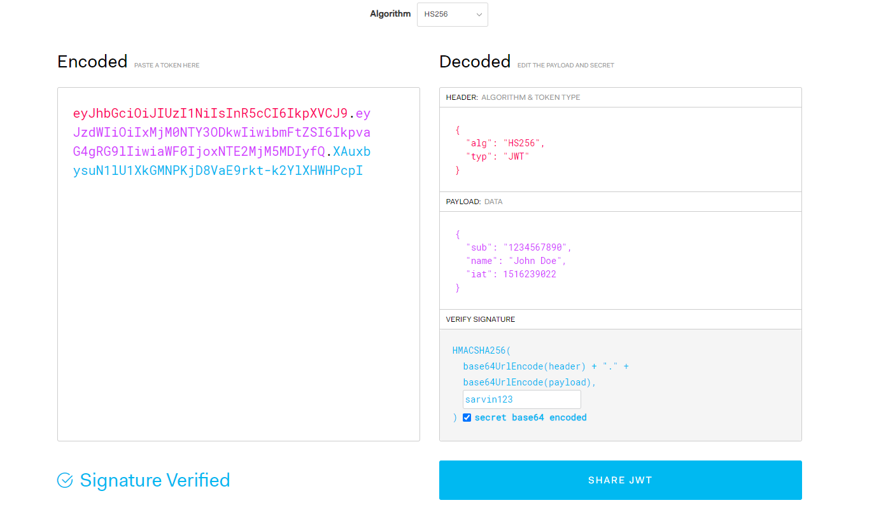

### Links

https://jwt.io/

## User specific action

## Implementing Advanced features

## Misc and Questions

### Interview Questions

### Redis Output caching

Reference youtube video: <https://www.youtube.com/watch?v=_bg5dGnudPs>